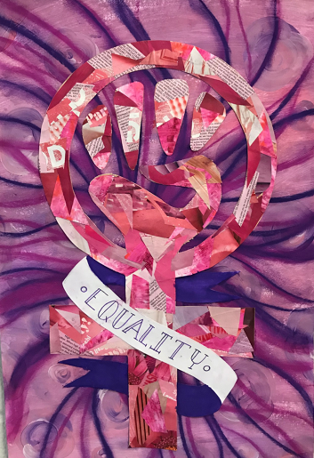
Social Issues Collage

Objective: Students will create a visual artwork using cut/or torn paper to convey a social issue.

What is a Social Issue?
A social issue is a problem that influences many individuals within a society. It's a common problem we see happening in our society. A social issue can be considered as a problem that influences many people and many people strive to solve the issue.

Example Social Issues:
Gender inequality, LGBTQ rights, homelessness, climate change, immigration, bullying, civil rights, childhood obesity, gun control, police brutality, vaccines, health care reform, animal rights abortion, nuclear power, war on drugs.

Guiding Questions:
Why is this an issue for the world?
What are your personal experience(s) with the issue?
What are some visual images that you could use in your collage to reflect your concerns?

