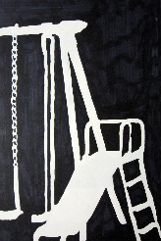  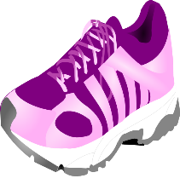  Draw your most interesting pair of shoes. | Set up 5 interesting kitchen objects in a still life. Draw ONLY the negative space around/between the objects (and through them if you see any holes). No shading or color needed! | 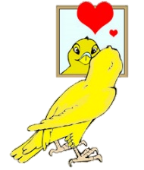  Draw a self-portrait from an unusual vantage point. Maybe your reflection in a spoon or other strange surface? Add shading. Color is optional. | 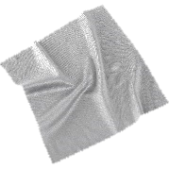  Find an object made of cloth that has creases or folds. Draw and shade the object so that the folds are visible.
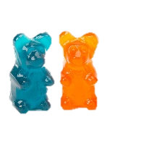  Find a group of at least 3 of the same small object (paperclips, push pins, gummy bears) and draw them SUPER CLOSE UP! The drawing should run off the page on at least 3 sides. | 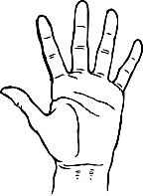  Draw your hand 3 or more times, changing the pose each time. Let the drawings overlap each other slightly on the page. | 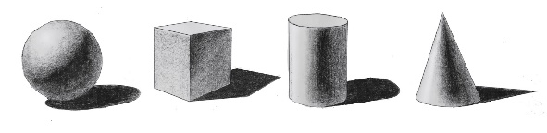  Carefully draw and shade a cone, cylinder, cube, and sphere. Include the cast shadow for each object. | Choose a large object (car, sofa, tree) and color it using complimentary colors. Use one color for light areas, and the opposite color for dark areas.
Find your favorite childhood toy and draw/shade using only ONE color! Do not use black or yellow. | 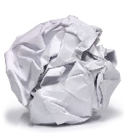  Draw and shade a crumpled piece of notebook paper. Use colored pencil to add the blue and red lines. | Open the  “junk drawer” in your room and draw what is inside. | Create 2 drawings using abstract shapes. One must have a symmetric composition, the other asymmetric. Add color using your medium of choice.
Draw your foot 3 or more times, changing the pose each time. Let the drawings overlap each other slightly on the page. | 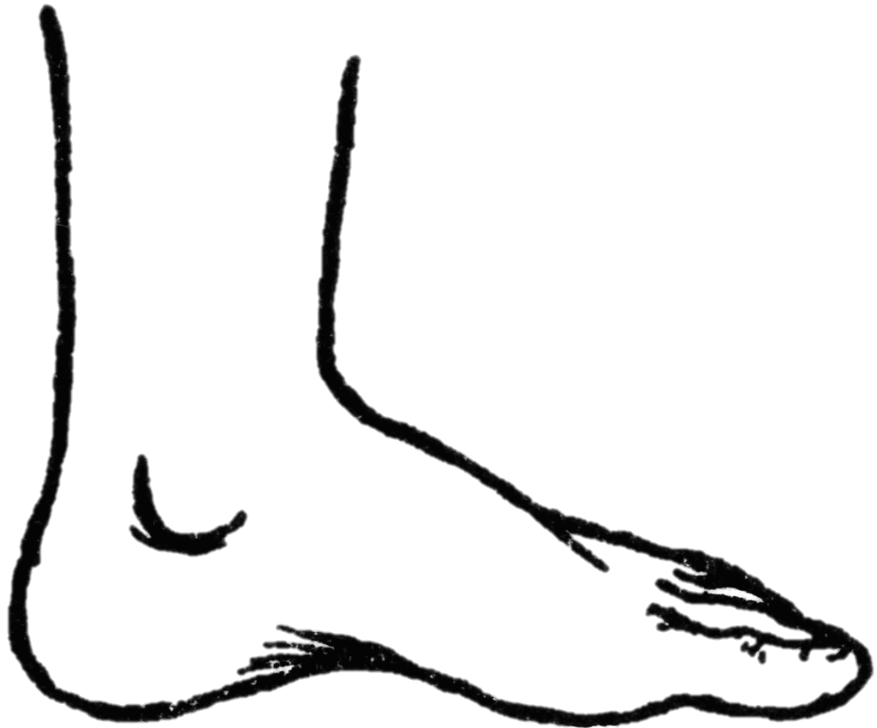  Create a portrait of a friend or family member doing something they enjoy. | Draw a hallway in your home. Include any doors, furniture, or decorations. | 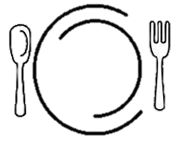  Photograph a typical meal you have at home, and draw it as realistically as you can.

￼

